# CS 255 System Design Document Template

## UML Diagrams

### UML Use Case Diagram

### UML Activity Diagrams

### UML Sequence Diagram

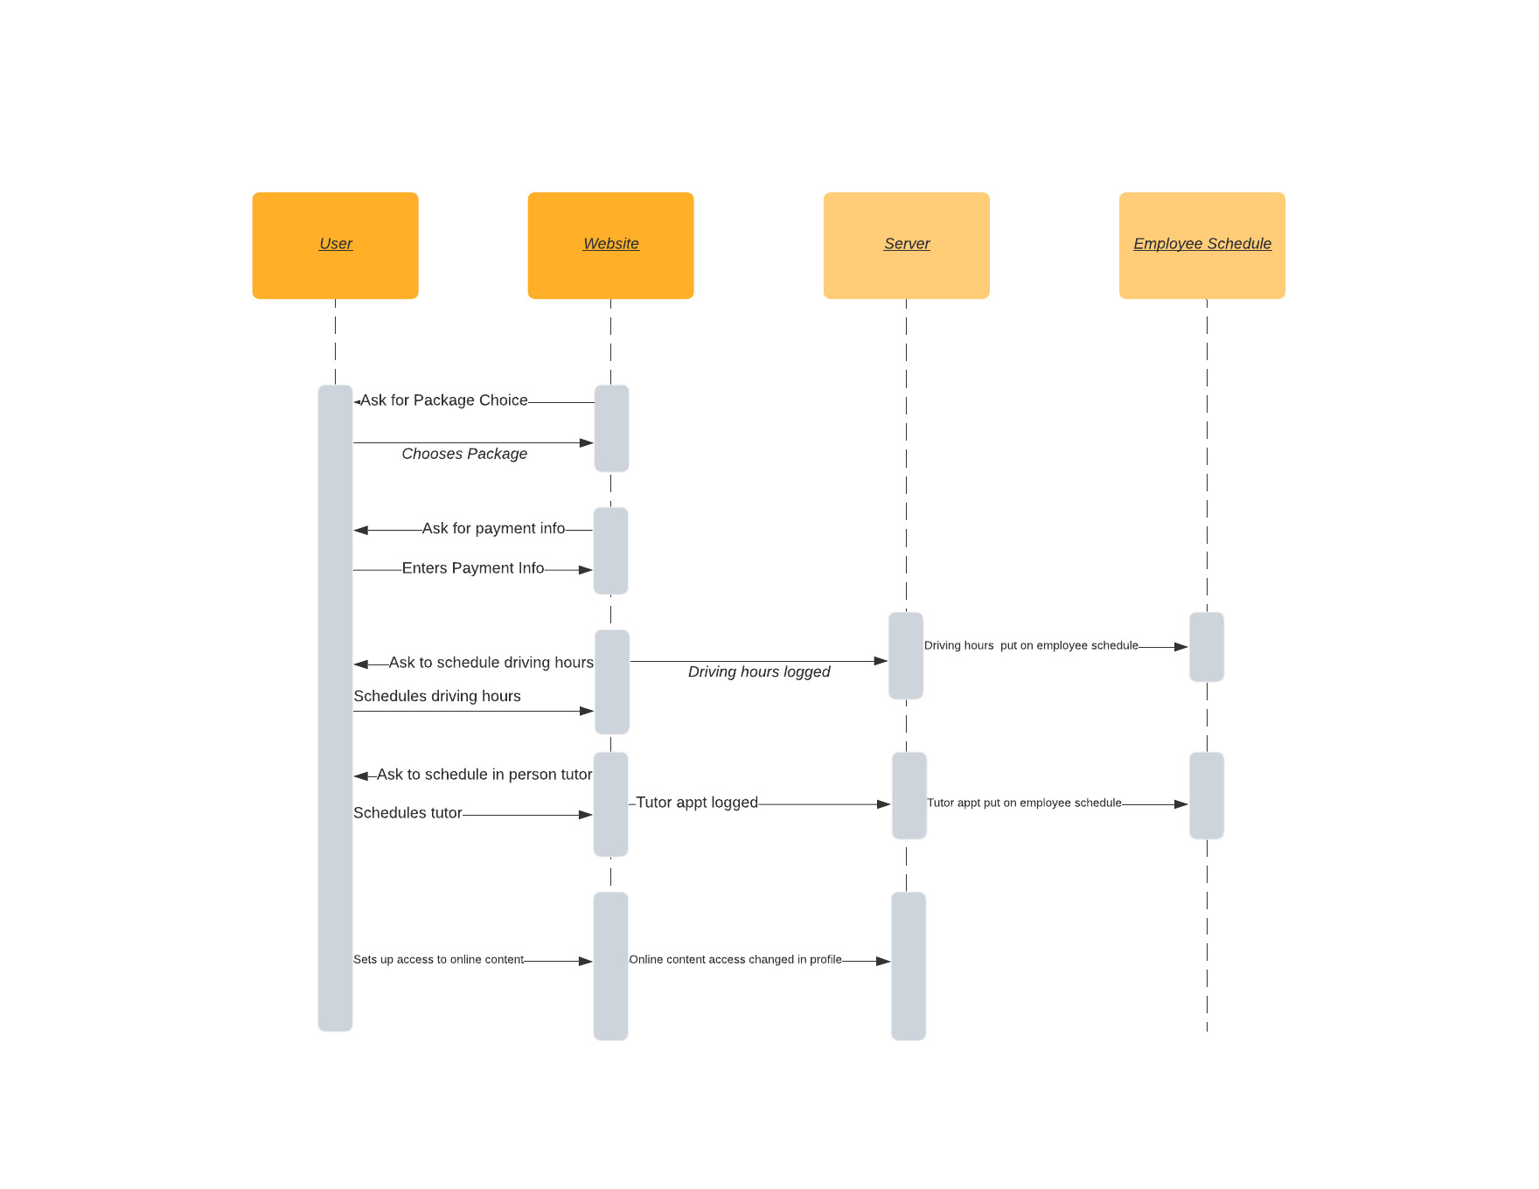

### UML Class Diagram

## Technical Requirements

* The system will be run on cloud servers
* The system will be based in Windows
* The system will work in conjunction with the existing DriverPass server.